EVERY FORCE EVOLVES FORM (SO DON’T FOLLOW THE PRESCRIPTION)
- 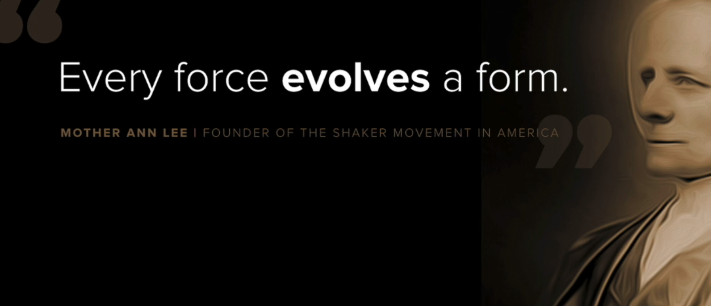
- Every force that influences our design(including bandwidth, time constraints, limitation in technology .e.t.c) evolves form
- 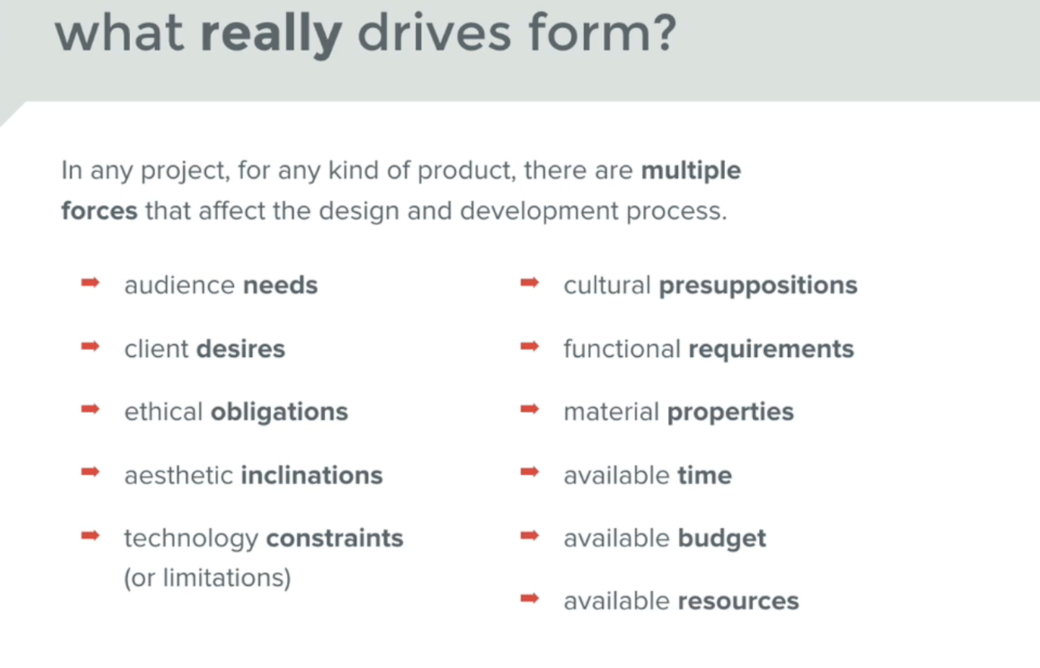
- 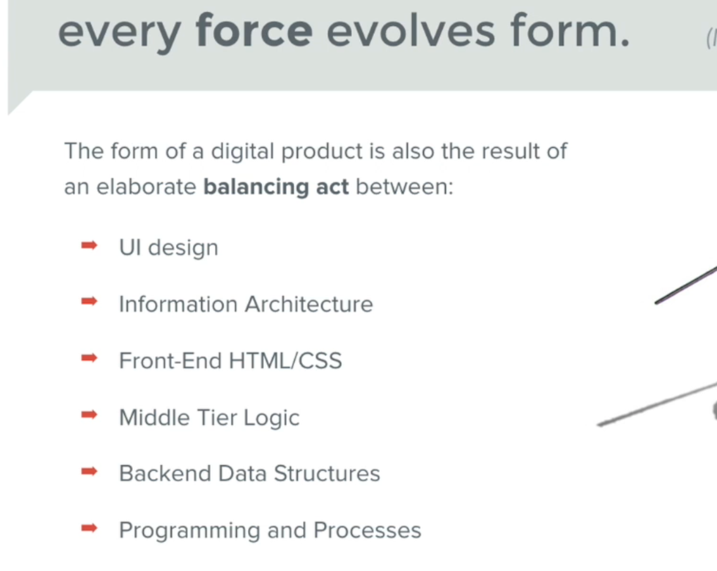
- 
- 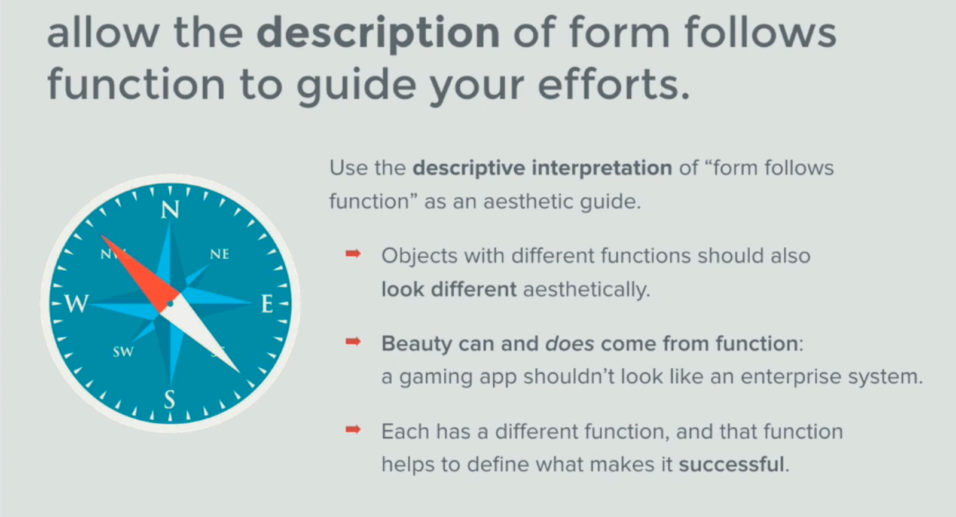
- UI design mantra 4: Every Force Evolves Form

